Final Year B.Tech. (CSE) – VII [2024-25]

**6CS452: High Performance Computing Lab**

Assignment No: 1

# Date: 05/08/2024

**Introduction to OpenMP**

**PRN:** 21510017  **Name:** Onkar Anand Yemul

**Title:** Introduction to OpenMP

OpenMP – Open Multi-Processing is an API that supports multi-platform shared-memory multiprocessing programming in C, C++ and Fortran on multiple OS. OpenMP uses a portable, scalable model that gives programmers a simple and flexible interface for developing parallel applications for platforms ranging from the standard desktop computer to the supercomputer.

**Problem Statement 1** – Demonstrate Installation and Running of OpenMP code in C

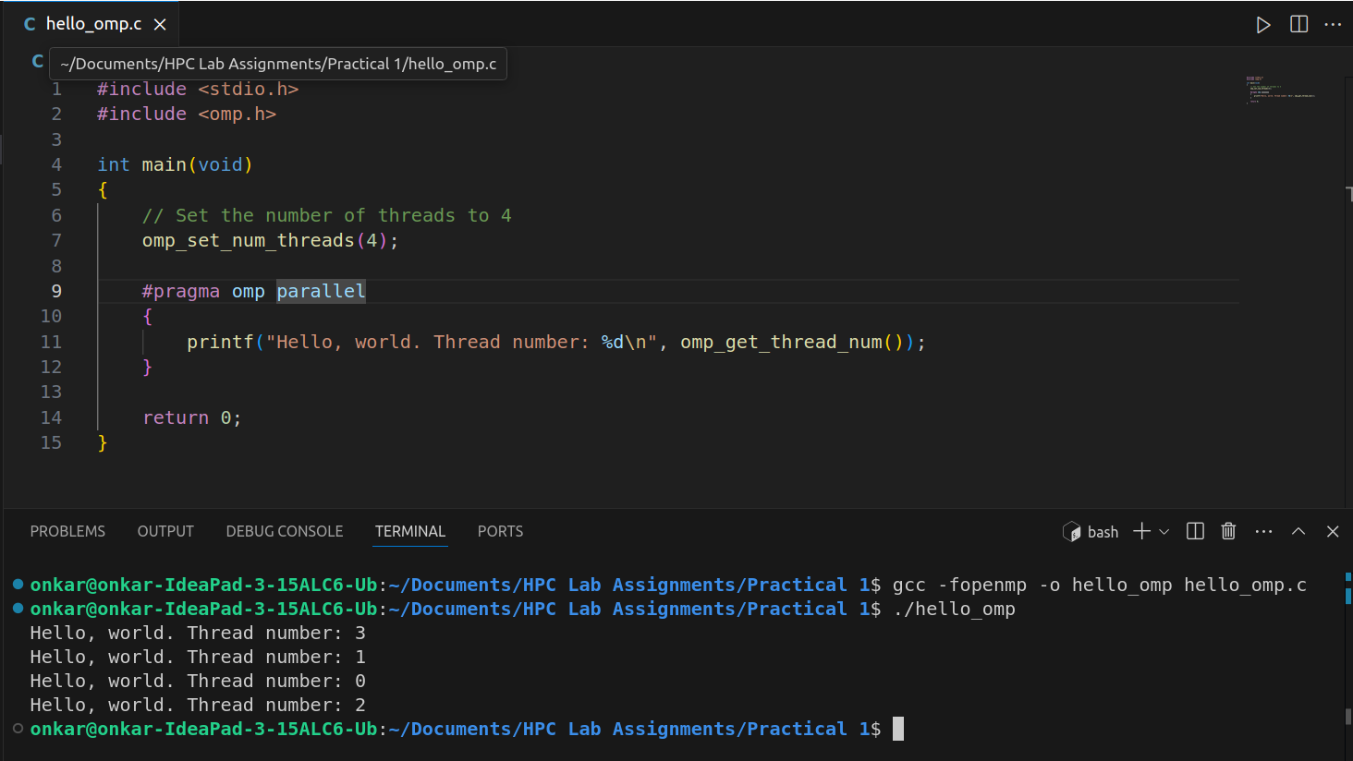

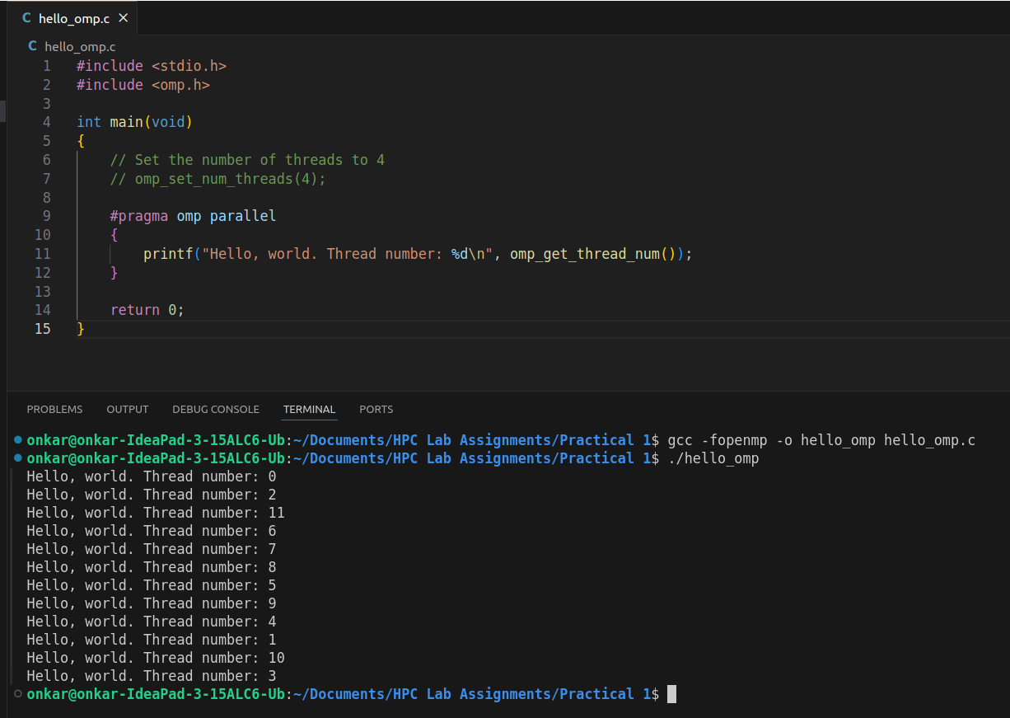

**Problem Statement 2** – Print ‘Hello, World’ in Sequential and Parallel in OpenMP

We first ask the user for number of threads – OpenMP allows to set the threads at runtime. Then, we print the Hello, World in sequential – number of times of threads count and then run the code in parallel in each thread.

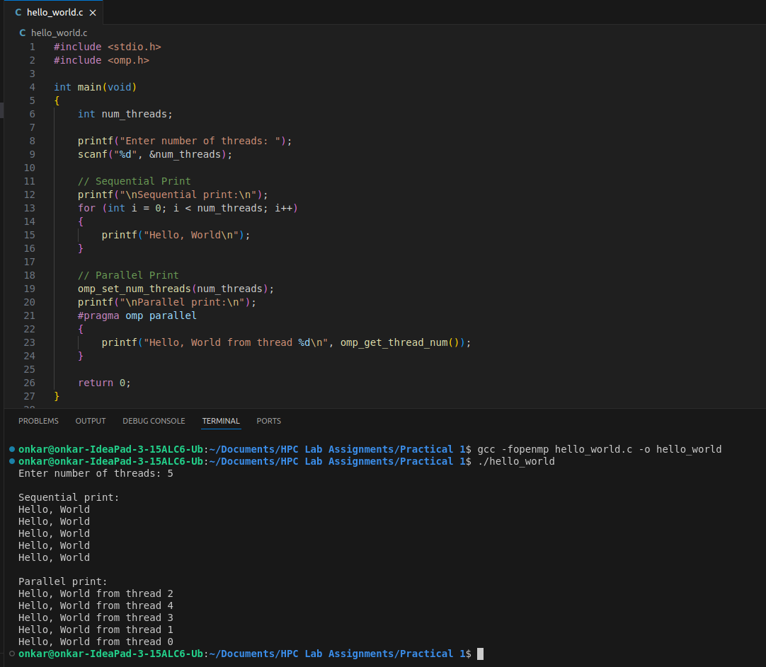

**GitHub Link:** Make a public repository upload code of an assignment and paste its link here.

**Problem statement 3:** Calculate theoretical FLOPS of your system on which you are running the above codes.

Elaborate the parameters and show calculation.

Steps:

1. Determine System Parameters:
   * Clock Speed (GHz): The speed at which the CPU operates.
   * Number of Cores: The total number of processing cores.
   * Floating Point Operations per Cycle (FLOP/cycle): This can vary but is often around 8 FLOP/cycle for modern processors with SIMD (Single Instruction, Multiple Data) units.
2. Theoretical FLOPS Calculation: The formula to calculate the theoretical FLOPS is:

Theoretical FLOPS = Clock Speed (GHz) × Number of Cores × FLOP/cycle × 10^9

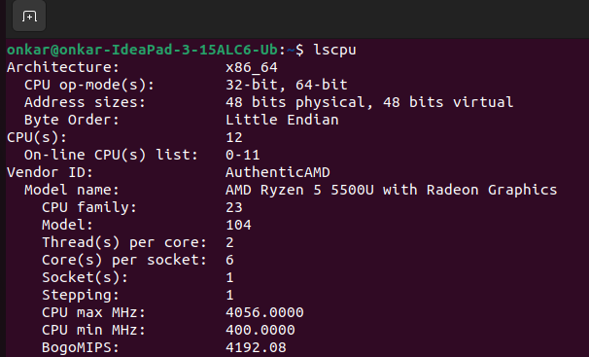

* Number of Cores (Cores per socket): 6 cores
* Threads per Core: 2 threads per core
* Total Number of Logical Processors (CPU(s)): 12 logical processors (cores × threads per core)
* Max CPU Frequency (CPU max MHz): 4056 MHz (or 4.056 GHz)
* FLOPs per cycle: Modern processors typically perform 8 FLOPs per cycle per core for double-precision operations .

**Theoretical FLOPS = Number of Cores × CPU Frequency (GHz) × FLOPs per cycle × 10^9**

Theoretical FLOPS = 6 × 4.056 × 8 × 10^9

= 194.688 × 10^9 FLOPS

= **194.688 GFLOPS**